**InsightStream: Navigate the News Landscape Ideation Phase**

**Brainstorm & Idea Prioritization**

|  |  |
| --- | --- |
| Date | 31 January 2025 |
| Team ID | 153816 |
| Project Name | Insight navigate the news landscape |
| Maximum Marks | 4 Marks |

**Brainstorm & Idea Prioritization Template:**

Brainstorming provides a free and open environment that encourages everyone within a team to participate in the creative thinking process that leads to problem solving. Prioritizing volume over value, out-of-the-box ideas are welcome and built upon, and all participants are encouraged to collaborate, helping each other develop a rich amount of creative solutions.

Use this template in your own brainstorming sessions so your team can unleash their imagination and start shaping concepts even if you're not sitting in the same room.

Reference: <https://www.mural.co/templates/brainstorm-and-idea-prioritization>

**Step-1: Team Gathering, Collaboration and Select the Problem Statement**

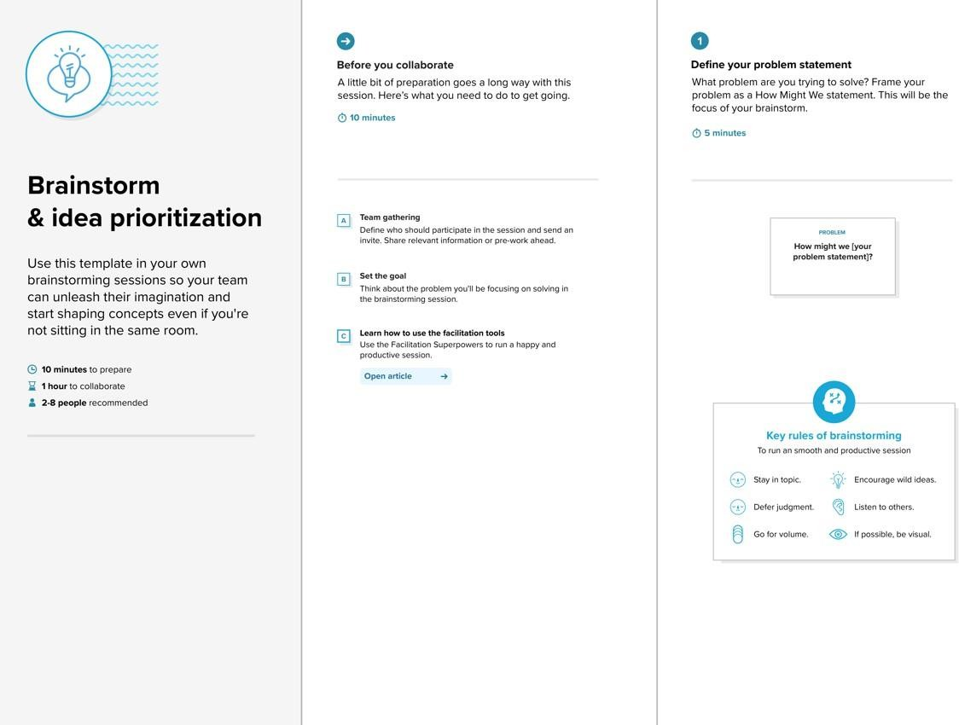

**Step-2: Brainstorm, Idea Listing and Grouping**

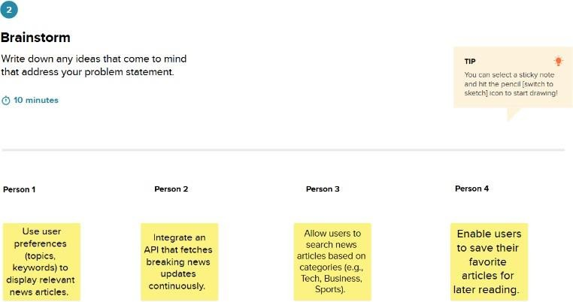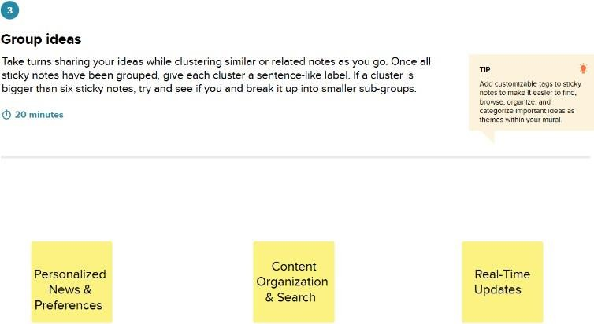

**Step-3: Idea Prioritization**

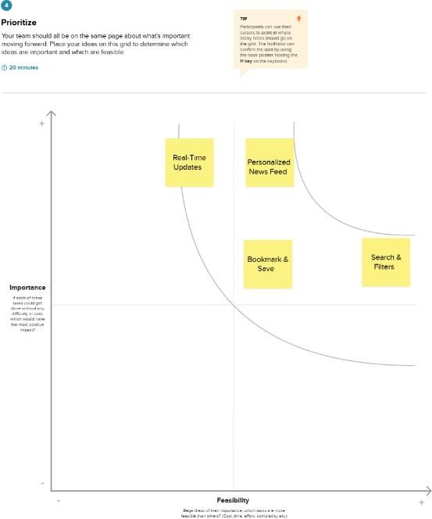

**InsightStream: Navigate the News Landscape Ideation Phase**

**Define the Problem Statements**

|  |  |
| --- | --- |
| Date | 5 March 2025 |
| Team ID | 153816 |
| Project Name | InsightStream navigate the News landscape |
| Maximum Marks | 2 Marks |

**Customer Problem Statement Template:**

Create a problem statement to understand your customer's point of view. The Customer Problem Statement template helps you focus on what matters to create experiences people will love.

A well-articulated customer problem statement allows you and your team to find the ideal solution for the challenges your customers face. Throughout the process, you’ll also be able to empathize with your customers, which helps you better understand how they perceive your product or service.

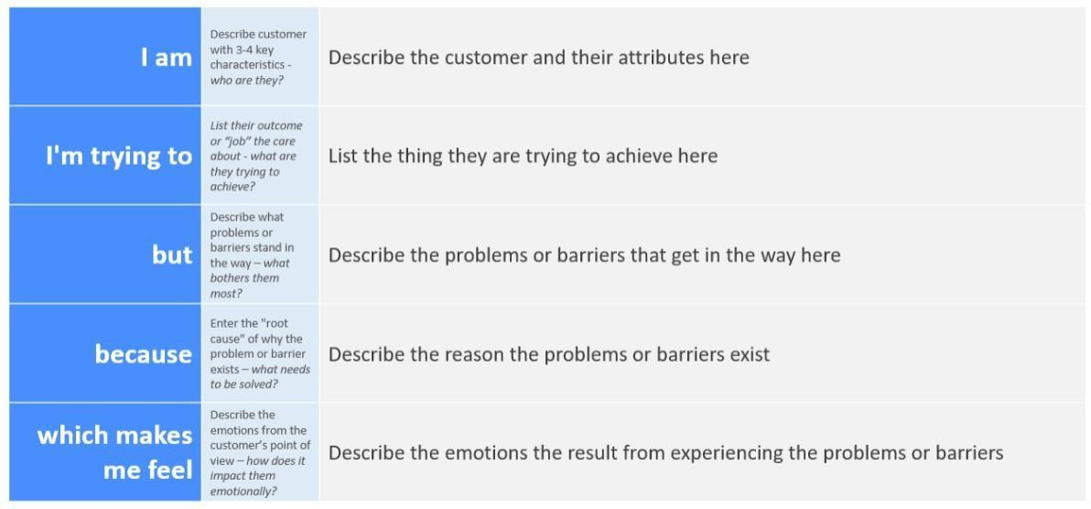

Reference: <https://miro.com/templates/customer-problem-statement/>

**Example:**

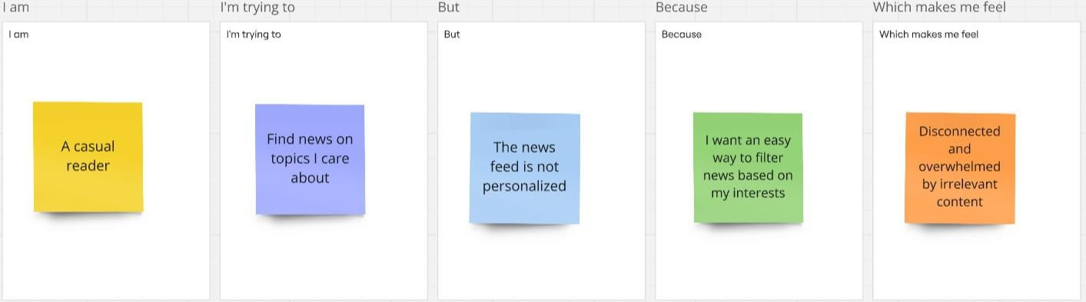

|  |  |  |  |  |  |
| --- | --- | --- | --- | --- | --- |
| **Problem Statement (PS)** | **I am (Customer)** | **I’m**  **trying to** | **But** | **Because** | **Which makes me feel** |
| **PS-1** | A busy professional | Stay updated with the latest news quickly | Most news websites are cluttered with ads and unnecessary content | I need a clean, distraction- free interface with only relevant news | Frustrated and unwilling to browse for long |
| **PS-2** | A casual reader | Find news on topics I care about | The news feed is not personalized | I want an easy way to filter news based on my interests | Disconnected and overwhelmed by irrelevant content |
| **PS-3** | A mobile user | Read news on the go | Many platforms are not mobile- friendly or take too long to load | I need a smooth, fast-loading, and responsive experience | Annoyed and likely to leave the platform |
| **PS-4** | A user concerned about credibility | Get reliable news from trusted sources | A lot of platforms spread misinformation or lack source transparency | I need verified news from reputable sources | Skeptical and unsure which news to trust |

**Project Design Phase-II**

**Data Flow Diagram & User Stories**

|  |  |
| --- | --- |
| Date | 31 January 2025 |
| Team ID | 153816 |
| Project Name | insightStream Navigate the News landscape |
| Maximum Marks | 4 Marks |

**Data Flow Diagrams:**

A Data Flow Diagram (DFD) is a traditional visual representation of the information flows within a system. A neat and clear DFD can depict the right amount of the system requirement graphically. It shows how data enters and leaves the system, what changes the information, and where data is stored.

**Example:**

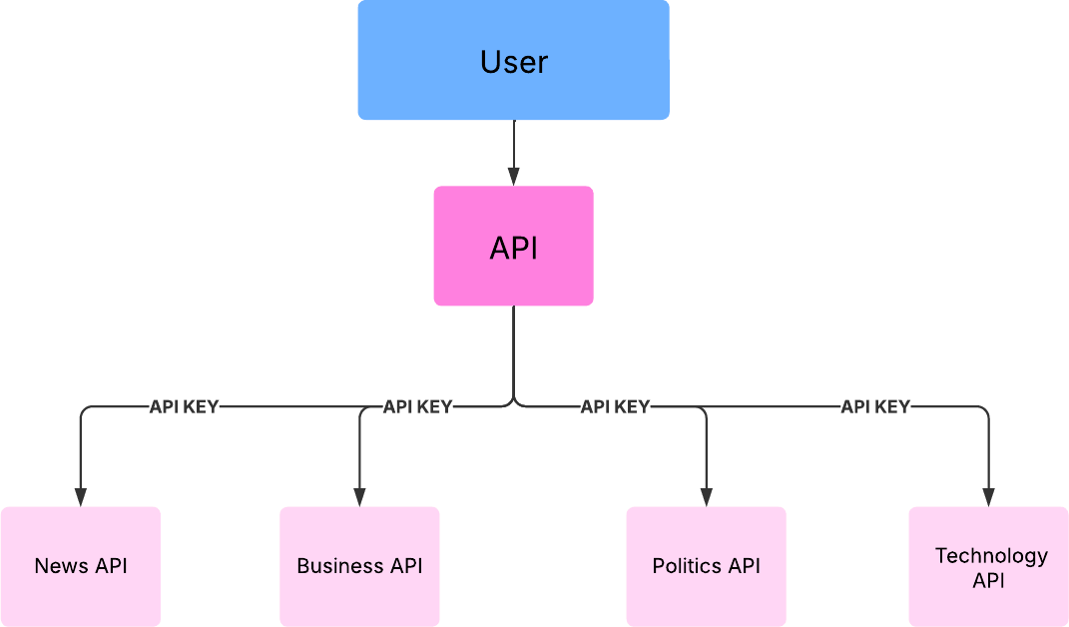

**User Stories**

**User Story Table – Music Streaming App**

|  |  |  |  |  |  |  |
| --- | --- | --- | --- | --- | --- | --- |
| **User Type** | **Functional Requiremen t (Epic)** | **User Story Numbe r** | **User Story / Task** | **Acceptance Criteria** | **Prio rity** | **Rele ase** |
| **News** |  | USN-1 | As a user, I can see the trendy news . | I can see the News of all topics. | High | Sprin t-1 |
| **Genre** |  | USN-2 | As a user, I can watch Political,Business, and Technology News. | I can also go the source and read the full news. | High | Sprin t-1 |
|  |  | USN-3 | As a user, I can able to view the complete news across the world. | I can also watch the news for multiple pages . | Medi um | Sprin t-2 |
| **Subscript ion** |  | USN-4 | As a user, I can even subscribe. | I can Subscribe to the newsletter for the news . | High | Sprin t-2 |

**InsightStream: Navigate the News Landscape Ideation Phase**

**Empathize & Discover**

|  |  |
| --- | --- |
| Date | 31 January 2025 |
| Team ID | 153816 |
| Project Name | InsightStream Navigate the News landscape |
| Maximum Marks | 4 Marks |

**Empathy Map Canvas:**

An empathy map is a simple, easy-to-digest visual that captures knowledge about a user’s

behaviours and attitudes.

It is a useful tool to helps teams better understand their users.

Creating an effective solution requires understanding the true problem and the person who is experiencing it. The exercise of creating the map helps participants consider things from the user’s perspective along with his or her goals and challenges.

**Example:**

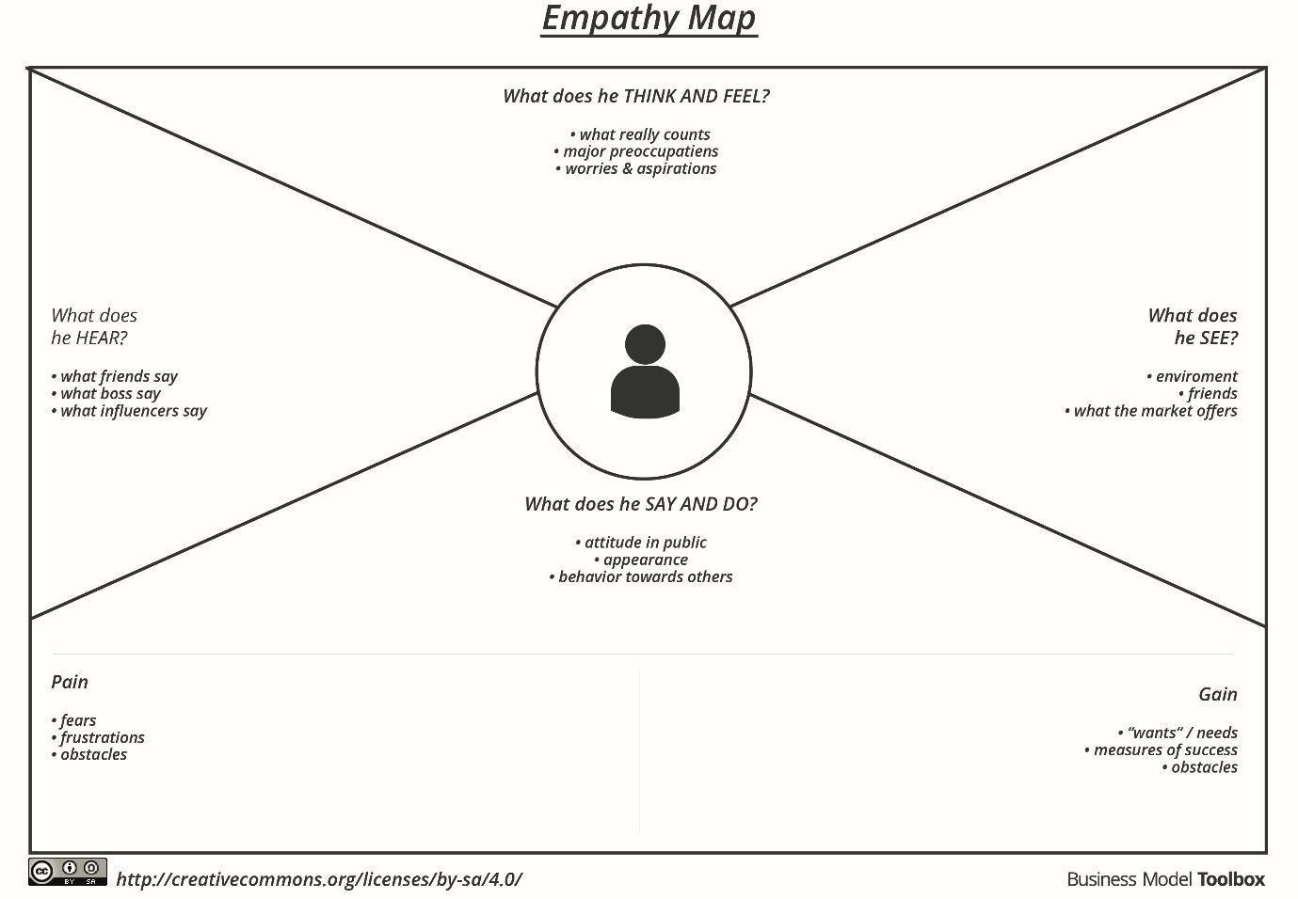

Reference: <https://www.mural.co/templates/empathy-map-canvas>

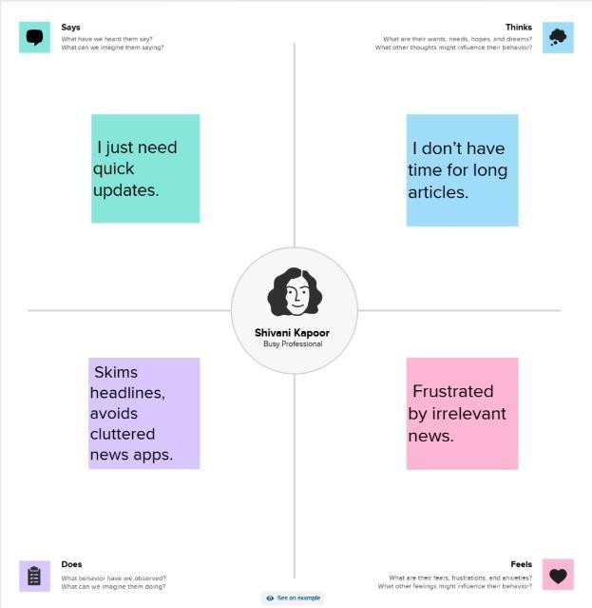

**Project Design Phase Problem – Solution Fit Template**

|  |  |
| --- | --- |
| Date | 6 March 2025 |
| Team ID | 153816 |
| Project Name | News App |
| Maximum Marks | 2 Marks |

**Problem – Solution Fit Overview:**

The **Problem-Solution Fit** ensures that the identified problem aligns with the needs of News App and that the proposed solution effectively addresses it. This validation is crucial before further development.

**Purpose:**

* Address the fragmented News, where users struggle to find a comprehensive platform that caters to diverse news tastes and offers personalized recommendations.
* Provide an intuitive and engaging platform for users to discover latest news ,courtesy without relying on multiple sources.
* Offer News based on category to enhance user engagement and satisfaction.
* Provide a platform that empowers independent journalists to gain exposure.
* Improve accessibility and engagement through an **interactive UI, responsive design, and well-structured data flow**.

**Problem Statement:**

Many music enthusiasts face challenges in finding a single platform that offers:

* A vast and diverse news platform.
* Accurate and top news .
* Genuine courtesy.
* A strong social community around news .
* Fair exposure for independent journalist.

**Solution:**

**“News App”**, a News app for web and mobile application, will provide:

* An extensive top News library through partnerships with major and independent record labels.
* Top and trendy news by default .
* Genuine courtesy reduces the chance of corrupted news.
* A freemium business model, that allows for free users.

**Project Planning Phase**

**Project Planning Template (Product Backlog, Sprint Planning, Stories, Story points)**

|  |  |
| --- | --- |
| Date | 15 February 2025 |
| Team ID | 153816 |
| Project Name | News app |
| Maximum Marks | 5 Marks |

**Product Backlog, Sprint Schedule, and Estimation (4 Marks)**

|  |  |  |  |  |  |  |
| --- | --- | --- | --- | --- | --- | --- |
| **Sprin t** | **Functional Requirement (Epic)** | **User Story Number** | **User Story / Task** | **Story Point s** | **Prio rity** | **Team Member s** |
| **Sprin t-1** | **News Categories** | USN-1 | As a user, I can read the news based on the category. | 20 | High | Tousif |
| **Sprin t-2** | **Default News** | USN-2 | As a user, I can see the trendy news at the default page . | 20 | High | Tousif |
| **Sprin t-3** | **News Browsing** | USN-3 | As a user, I can read the complete article with courtesy. | 20 | High | Tousif |
| **Sprin t-4** | **Subscription** | USN-4 | As a user, I can Subscribe to the news letter. | 20 | High | Tousif |

**Project Tracker, Velocity & Burndown Chart**

|  |  |  |  |  |  |  |
| --- | --- | --- | --- | --- | --- | --- |
| **Sprint** | **Total Story Points** | **Durat ion** | **Sprint Start Date** | **Sprint End Date (Planned)** | **Story Points Completed (as on Planned End Date)** | **Sprint Release Date (Actual)** |
| **Sprint- 1** | 20 | 6  Days | 1 Mar  2025 | 2 Mar 2025 | 20 | 2 Mar 2025 |
| **Sprint- 2** | 20 | 6  Days | 3 Mar  2025 | 4 Mar 2025 | 20 | 4 Mar 2025 |
| **Sprint- 3** | 20 | 6  Days | 5 Mar  2025 | 6 Mar 2025 | 20 | 6 Mar 2025 |
| **Sprint- 4** | 20 | 6  Days | 7 Mar  2025 | 8 Apr 2025 | 20 | 8 Apr 2025 |

**Project Design Phase Proposed Solution Template**

|  |  |
| --- | --- |
| Date | 15 February 2025 |
| Team ID | 153816 |
| Project Name | News App |
| Maximum Marks | 2 Marks |

**Proposed Solution for Music Streaming App**

|  |  |  |
| --- | --- | --- |
| **S. No.** | **Parameter** | **Description** |
| **1** | **Problem Statement** (Problem to be solved) | Users often struggle to find accurate news and genuine courtesy. News app provides a full fledged top news and the news based on the genre  .The open source third party news api provides the service for fetch and news and the news based on the category. |
| **2** | **Idea / Solution Description** | The News app is a React-based frontend solution that allows users to search, stream, and manage the news. It leverages a third-party API to fetch news and ensures an intuitive and interactive UI/UX for a seamless experience. |
| **3** | **Novelty / Uniqueness** | - **Top news** using open source third party API - **Intuitive UI/UX** with responsive design across devices - **Cross-Platform Support** for both mobile and web users - **Seamless Integration** with third-party News APIs for vast content availability |
| **4** | **Social Impact**  **/ Customer Satisfaction** | - Provides an **ad-free news experience** with multiple categories- **Brings emerging courtesy** to a wider audience through latest news - **Increases user engagement** through category based news. |
| **5** | **Business Model (Revenue Model)** | - **Freemium Model**: Free tier with No ads,for enjoying ad free news and news based categories. |
| **6** | **Scalability of the Solution** | - Can be **expanded globally** by integrating multiple third-party news APIs - Supports for enhanced personalization - Can be extended to **mobile applications** for iOS & Android using React Native - Potential integration with **AI-driven recommendation engines** for improved user experience |

**Project Design Phase Solution Architecture**

|  |  |
| --- | --- |
| Date | 15 February 2025 |
| Team ID | 153816 |
| Project Name | News app |
| Maximum Marks | 4 Marks |

**Solution Architecture:**

The solution architecture for news app, the news Application, ensures a **scalable, high- performance, and immersive platform** for getting news from genuine sources and personalized playlists. The architecture prioritizes seamless audio delivery, real-time recommendations, and cross-device synchronization to enhance user engagement.

* Find the best tech solution to solve existing business problems.
* Describe the structure, characteristics, behavior, and other aspects of the software to project stakeholders.
* Define features, development phases, and solution requirements.
* Provide specifications according to which the solution is defined, managed, and delivered.

**Example - Solution Architecture Diagram:**

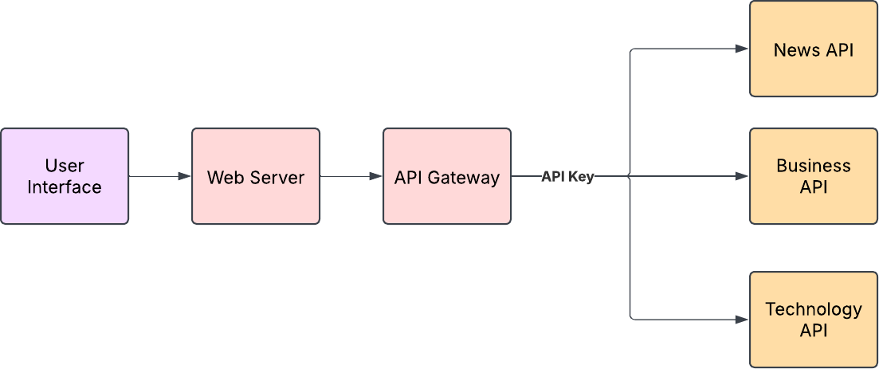

**Project Design Phase-II**

**Solution Requirements (Functional & Non-functional)**

|  |  |
| --- | --- |
| Date | 31 January 2025 |
| Team ID | 153816 |
| Project Name | InsightStream navigate the News landscape |
| Maximum Marks | 4 Marks |

**Functional Requirements:**

Following are the functional requirements of the proposed solution.

**Functional Requirements – News App**

|  |  |  |
| --- | --- | --- |
| **FR No.** | **Functional Requirement (Epic)** | **Sub Requirement (Story / Sub-Task)** |
| **FR-1** | **News Home** | Top News |
| **FR-2** | **News Genre** | General,Health,Technology,Politics,Art & Culture |
| **FR-3** | **NewsLetter** | NewsLetter subscription |

**Non-functional Requirements:**

Following are the non-functional requirements of the proposed solution.

|  |  |  |
| --- | --- | --- |
| **NFR**  **No.** | **Non-Functional Requirement** | **Description** |
| **NFR- 1** | **Usability** | The app should have an intuitive and user-friendly interface, ensuring smooth navigation and accessibility for users of all demographics. |
| **NFR- 2** | **Security** | User authentication and data must be secured using encryption (e.g., HTTPS, OAuth for third-party logins). The app should prevent unauthorized access and follow best security practices. |
| **NFR- 3** | **Reliability** | The app should ensure a consistent and uninterrupted music streaming experience, minimizing crashes and downtime. |
| **NFR- 4** | **Performance** | Songs should load and stream with minimal buffering. The app should respond to user interactions (search, playback, playlist management) within 2 seconds. |

|  |  |  |
| --- | --- | --- |
| **NFR- 5** | **Availability** | The system should maintain an uptime of at least 99.9%, ensuring accessibility across different time zones. |
| **NFR- 6** | **Scalability** | The app should handle increasing numbers of users and concurrent streams efficiently without performance degradation. The architecture should support future feature expansion. |

**Project Design Phase-II Technology Stack (Architecture & Stack)**

|  |  |
| --- | --- |
| Date | 31 January 2025 |
| Team ID | 153816 |
| Project Name | News App |
| Maximum Marks | 4 Marks |

**Technical Architecture:**

The Deliverable shall include the architectural diagram as below and the information as per the table1 & table 2

**Example:** News App

**Table-1 : Components & Technologies:**

|  |  |  |  |
| --- | --- | --- | --- |
| **S.N**  **o** | **Component** | **Description** | **Technology** |
| 1. | User Interface | Web-based interface for News | HTML, CSS, JavaScript /  React Js etc. |
| 2. | Application Logic-1 | News fetching from News api | React js |
| 3. | Application Logic-2 | News fetching based on genre | React js |

**Table-2: Application Characteristics:**

|  |  |  |  |
| --- | --- | --- | --- |
| **S.N**  **o** | **Characteristics** | **Description** | **Technology** |
| 4. | Open-Source Frameworks | Frontend frameworks | React.js, BootStrap, Tailwind CSS |

**References:**

[**React.js Documentation**](https://react.dev/)

**User Acceptance Testing (UAT) Template**

|  |  |
| --- | --- |
| Date | 6 March 2025 |
| Team ID | 153816 |
| Project Name | News app |
| Maximum Marks |  |

**Project Overview**

’)c **Project Name:** News app

)’c **Project Description:** A React-based news application that allows users to search, track, and analyse real-time news data using a third-party API.

)c’**Project Version:** v1.0

’)c **Testing Period:** March 1, 2025 - March 8, 2025

**Testing Scope**

**Features and Functionalities to be Tested**

✓⬛Home Page & Navigation

⬛✓ News Category

✓⬛ API Integration for Real-Time news

⬛✓ API key to access the api

* Watching News based on category.

✓⬛ UI/UX Testing (Responsiveness, Icons, Styling)

✓⬛ Error Handling & Performance Testing

**User Stories or Requirements to be Tested**

)c’Viewing global news.

)’cWatching news based on the category

’)c Getting newsletter based on subscription

’)c Responsive UI across Mobile, Tablet, and Desktop

’)c Handling API Errors Gracefully

**Test Cases**

|  |  |  |  |  |  |
| --- | --- | --- | --- | --- | --- |
| **Test Case ID** | **Test Scenario** | **Test Steps** | **Expected Result** | **Actual Result** | **Pass/Fail** |
| **TC-001** | Load Homepage | 1. Open the application 2. Homepage | Homepage should display all the news. | [Actual Result] | [Pass/Fail] |

|  |  |  |  |  |  |
| --- | --- | --- | --- | --- | --- |
|  |  | loads |  |  |  |
| **TC-002** | Category | 1. Select the news category | Get the news based in the category | [Actual Result] | [Pass/Fail] |
| **TC-003** | Subscription | 1. Get the newsletter | Get the subscription newsletter. | [Actual Result] | [Pass/Fail] |
| **TC-004** | Mobile Responsiveness | 1. Open the app on a mobile device 2. Navigate through pages | UI should be responsive and properly displayed | [Actual Result] | [Pass/Fail] |

**Bug Tracking**

|  |  |  |  |  |  |
| --- | --- | --- | --- | --- | --- |
| **Bug ID** | **Bug Description** | **Steps to Reproduce** | **Severity** | **Status** | **Additional Feedback** |
| **BG- 001** | results take too long to load | 1. Results won’t load. 2. Observe slow response time | High | Open | Need API Key |
| **BG- 002** | News will not load. | 1. Click on category 2. Observe incorrect results | Medium | In Progress | Filtering logic needs debugging |
| **BG- 003** | UI overlaps on small screen devices | 1. Open app on small devices (iPhone SE) 2. Observe UI distortion | Low | Open | Adjust CSS for better responsiveness |

**Sign-off**

**Tester Name:** [Enter Name] **Date:** [Enter Date of Completion] **Signature:** [Enter Signature]

**Notes**

* + Ensure testing covers both positive & negative cases
  + Bug tracking should include severity levels & reproduction steps
  + Final sign-off required before deployment